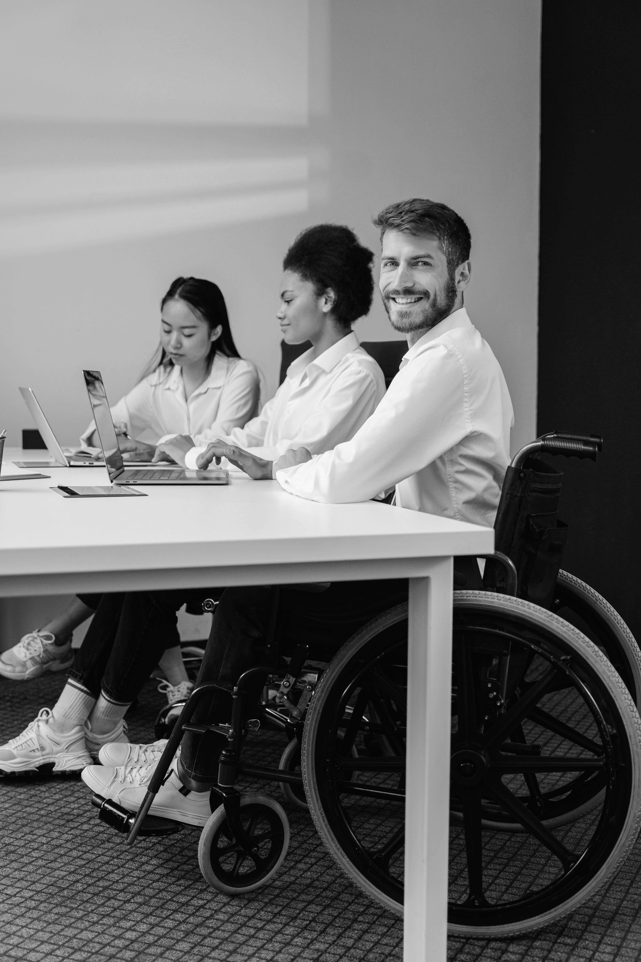
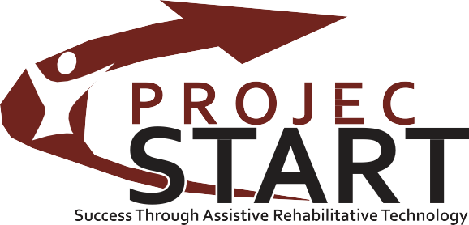
ANNUAL REPORT 2024

TABLE OF CONTENTS
3 Welcome
- Device Reutilization
- Device Loan Program
- Device Demonstration
- Training Participants

Mission Statement
It is the express mission of Project START to empower Mississippians with disabilities through education, awareness and access to Assistive Technology.

Vision Statement
Mississippi Project START (Success Through Assistive Rehabilitative Technology) was established to provide information about assistive technology to consumers and other interested parties so they may make informed decisions about available assistive technology services.



Billy Taylor
Executive Director Letter from our Executive Director

Dear friends,

I am pleased to present the 2024 Annual Report for the Mississippi Department of Rehabilitation Services’ Project START, also known as the Mississippi Technology Act Program. START stands for Success Through Assistive Rehabilitative Technology.

Project START is a program administered by the Mississippi Department of Rehabilitation Services which provides Mississippians with disabilities access to assistive technology. Assistive Technology includes mobility devices, such as wheelchairs, accessibility software, technology for low vision and blindness, and augmentative and alternative communications devices.

For many children and adults with disabilities, access to and acquisition of assistive technology can make a tremendous difference in their ability to fully participate in employment, school, and recreational activities. The right tools-very specialized devices-allow individuals with disabilities to live, learn, work, and play independently.

Please see what great things we have done together this past year, and know that your continued support of Project START is vital to our mission and to what we can accomplish in the next year.

Sincerely,





Jamie Tucker
Director Letter from our Director

It is my pleasure to share with you our 2024 annual report highlighting the accomplishments of Mississippi’s Assistive Technology Act Program, Project START. Working with and providing services for Mississippians with disabilities is a true blessing. Each day Project START strives to ensure every individual has the opportunity to live their life to the fullest through the assistance of assistive technology.

I would personally like to thank Mr. Billy Taylor, Executive Director of Mississippi Department of Rehabilitation Services, and his dedicated employees for their hard work and support of our program. Also, thank you to our Advisory Council for their guidance and support, and last but not least, our dedicated staff who work tirelessly every day to assist Mississippians with a disability.

As the director of Project START, I am excited about some additions to our program for the coming year and invite you to first our website at msprojectstart.org for more information about our services and upcoming events. You can contact us at any time through our website or by calling our office at 601.853.5249 or 1.800.852.8328 or emailing me directly at jtucker@mdrs.ms.gov.

Jamie Tucker, Director Project START

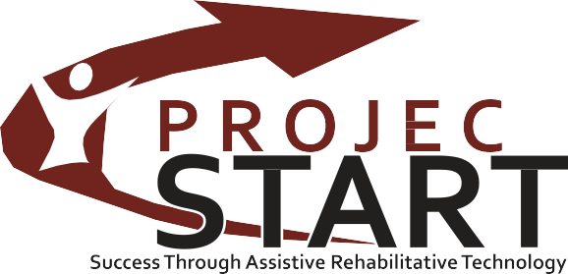

Device Reutilization
The Device Reutilization program focuses on the under-served populations in Mississippi with the mission to provide education, awareness and access of assistive technology to individuals with limited resources in their community. The program redistributes used equipment that has been sanitized, checked for safety and refurbished for appropriate use.

Device Reassignment/Refurbishment
Mobility, Seating, and Positioning 11
Daily Living 6
Computer and Related 47
Vision 0
Customer Satisfaction
Highly Satisfied 64
Satisfied 0
Somewhat Satisfied 0
Total Surveyed 64

Testimonial
Project START continues to provide it's computer refurbishment program that is unique to MS's Assistive Technology Act Grant program. Laptops, Chromebooks and desktops are donated to our program that are in turn wiped clean and updated with the latest operating systems. We are able to donate these to Mississippians with disabilities in need for educational, occupational or community needs.

In addition to the computer refurbishment program, START frequently reutilizes various DME equipment for mobility, vision and activities of daily living as donations are made by individuals who wish for their valued equipment in turn be donated to another individual in need. Several pediatric wheelchairs were sanitized and donated to kids in dire need in 2024. The savings to MS consumers who utilized our reuse/reutilization program for FY24 were
$61,216.00.
5

Device Loan Program
Project START provides a short term equipment loan program allowing an individual to try a device before they purchase it. This program also allows an individual to borrow a device to use while theirs is being repaired or while funding is being secured for the purchase of their device.

Device Loans by Type or Borrower

Individual with Disabilities
Family members, Guardians &
109
Purpose of Devices Loaned
Assist in Decision Making

Authorized Representatives 13
Representatives of Education 7
Representatives of Employment 0
Representative of Health,
Allied Health & Rehabilitation 2
Representative of Community Living 0
Representative of Technology 0
(device trail or evaluation)
Serve as Loaner During Device Repair or While Waiting for Funding
Provide an Accommodation on a Short-Term Basis
Conduct training, self education or other professional development activity
109

7

11

7

Types of Devices Loaned
Vision 43
Hearing 1
Speech Communication 22
Learning, Cognition, & Positioning 34
Mobility, Seating, & Position 60

Customer Satisfaction

Highly Satisfied Satisfied
Satisfied Somewhat Not at all satisfied Non respondent

126
6
0
0
2

Total 134
Daily Living | 21
Environmental Adaptions | 0
Vehicle Modification & Transportation | 0
Computers & Related | 4
Recreation Sports & Leisure | 0
Total | 185

Testimonial

The North MS Regional Center's TAD Center continues to be an integral part of the of the Project START mission and valuable subcontractor in the efforts to put assistive technology in the hands of individuals with disabilities. Twin eight-year-old girls came into the center who have a diagnosis of Autistic Disorder. English is a second language for the family.

They produced some echolalia and rote speech (e.g. "one, two, three go") in both English and Spanish. They attended a demonstration due to their insurance requiring a trial with a communication device prior to purchasing. Although the had been using LAMP Words for Life low tech board in the classroom this didn't qualify for the trial. We were able to loan a device to the school for the girls to trial in the classroom. Both girls did well with the device, especially in one-on-one situations, learning to make requests and identify items and emotions. The speech-language pathologist relayed the following story:
During the eclipse lesson in class the therapist did therapy in the classroom setting. Child "A" did not want to use the device, and the therapist prompted her to identify emotions and why she was upset. She proceeded to say afraid and attempted to say sun. She was able to express how she was feeling about the eclipse video she was watching in class. We all sometimes have difficulty expressing our emotions, but this is especially challenging for individuals with Autistic Disorder. Using the trial communication device, she was able to communicate how she felt when no one would have known she
was afraid without it. 6

Device Demonstration
In addition to our offices at the Mississippi Department of Rehabilitation Services in Madison, our partnerships provide Demonstration Centers throughout the state to educate individuals and their families or caregivers on assistive technology to aid in hearing, mobility, communication, vision and performing activities on daily living.

Demonstrations By Device Type

Vision | 8
Hearing | 0
Speech Communication | 65
Learning, Cognition, & Developmental | 20
Mobility, Seating, & Position | 40
Daily Living | 6
Environmental Adaptions | 0
Vehicle Modification & Transportation | 56
Computers & Related | 23
Recreation Sports & Leisure | 2
Total | 220

Types of Participants

Individual with Disabilities
Family members, Guardians & Authorized Representatives
Representatives of Education

223

69
7

Customer Satisfaction

Highly Satisfied Satisfied
Satisfied Somewhat Not at all satisfied Non respondent

44
175
6
1
77

Representatives of Employment 2
Representative of Health,
Allied Health & Rehabilitation 0
Representative of Community Living 2
Representative of Technology 0
Total 303

Total 303

Testimonial

Our coastal demo and loan center, IDS, provided a client with the necessary skills and confidence to effectively use a floating beach wheelchair, ensuring they could enjoy beach environments easily and independently. Its unique features, including its buoyancy and all-terrain wheels for sandy and aquatic environments were emphasized as well as the wheelchair's purpose in providing safe and comfortable mobility on beaches and in shallow water. Seats can be adjusted for optimal comfort and support, and safety features such as the seatbelt, armrests, and braking system were highlighted detailing the importance in ensuring stability and security.
7

Training Participants
Project START provides training, technical assistance and public awareness activities, providing information on availability, benefits and cost of AT devices and services.

Total Training Participants

Individual with Disabilities
Family members, Guardians & Authorized Representatives
Representatives of Education Representatives of Employment
Representative of Health, Allied Health & Rehabilitation
Representative of Community Living Representative of Technology
163

0
70
0

0
0
29

Unable to Categorize Trainees 310
Total 572
310 trainees on general AT, AAC, driving, adaptive computer access, vision and hearing, and AT for learning disabilities were not able to be categorized

Testimonial

Project START's subcontractor, Mississippi State University's T.K. Martin Center for Technology and Disability, hosted an event for students with disabilities to experience hands-on career exploration activities during the job extravaganza from virtual driving to budgeting games. More than 20 students participated and engaged in interactive simulators, AT devices and activities designed to promote technical and practical skills used in the workplace. Additionally, Chick Fil A and Build Mississippi facilitated breakout sessions covering job exploration counseling, workplace readiness training and self-advocacy. This event was meticulously designed to be inclusive and engaging, showcasing a variety of career opportunities through fun and tailored activities with each station. This marked the first in a series planned by the center in partnership with MDRS as an inclusive outreach to students with disabilities in Northeast MS.
8

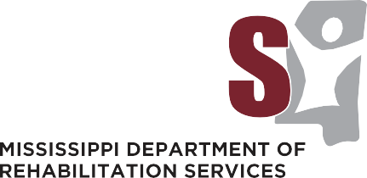

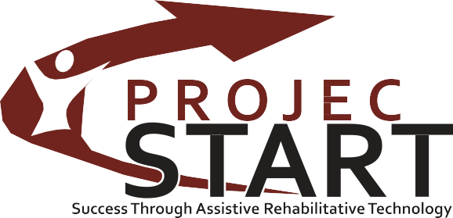
Your perspective is extremely valuable,
and we greatly appreciate any and all feedback!

Please send any comments or questions to:
Jamie Tucker jtucker@mdrs.ms.gov
Post Office Box 1698 | Jackson, Mississippi 39215-1698 1.800.852.8328 (in MS only) | www.msprojectstart.org

Mississippi Project START is funded under the Assistive Technology Act of 1998, as amended by the U.S. Department of Education, Rehabilitation Services Administration.

MDRS Project START, the statewide assistive technology program for Mississippians, is coordinated by the Mississippi Department of Rehabilitation Services agency

