SECTION 3.14: POST-SECONDARY EDUCATION AND TRAINING SERVICES

The Offices of Vocational Rehabilitation (OVR) and Vocational Rehabilitation for the Blind (OVRB) sponsor postsecondary education (PSED) that occurs at an accredited post-secondary educational institution or proprietary school for individuals who are determined eligible for VR/VRB services.

The procedures included in this section are guidelines for providing PSED and training services when these services are necessary for an individual to prepare for, secure, retain, advance in, or regain employment. Individuals interested in obtaining PSED and/or training services must agree to actively participate in career exploration, research of the labor market, and assessment(s) if necessary to determine an employment goal that is achievable and consistent with the individual’s strengths, resources, priorities, concerns, abilities, capabilities, interests, and informed choice.

NOTE: All PSED students who are twenty-one (21) years of age or younger that did not receive Pre-Employment Transition Services (Pre-ETS) as a high school student, or those who are currently in need of such services should have them planned on his/her IPE. Pre-ETS may be provided by the students’ VR/VRB counselor or a chosen third-party provider.

TYPES OF PSED PROGRAMS:

PSED includes academic, career, and technical training programs at an accredited postsecondary educational institution or training facility.
Academic | Successful completion of coursework leads to an Associate of Arts, Baccalaureate, or higher degree.
Career | Successful completion of coursework leads to a certificate in a particular business skill area (e.g. automotive technology, barber/stylist, graphic design, office clerk, small engine repair, welding, etc.). It usually provides specific short-term, job-related instruction but does not include broad-based academic courses. Courses such as these are not usually accepted for credit by academic degree programs.
Technical | Successful completion of combined academic and technical coursework leads to a one-year or two-year technical certificate or a two-year technical Associate in Applied Science Degree.
Proprietary School | Proprietary School sells vocational/occupational courses of instruction, exceeding twenty (20) clock hours in length to the general public for the purpose of training or preparing persons for gainful employment. A Proprietary School is a private, non-public business enterprise owned by one person, a partnership, limited liability corporation, or a corporation.

ACCREDITATION STANDARDS

The agency will not authorize funds to an institution (school) that is not accredited, licensed, or approved by the appropriate accrediting or licensing authority. Schools with provisional accreditation may be used; however, the counselor is to use caution when individuals elect to attend one of these schools. If a school loses its accreditation during the school year, the counselor is to notify the individual immediately and agency funds will cease at the end of that semester. The counselor is also advised to contact his or her manager who will then contact the PSED Program Coordinator to assist in determining when (or if) a school that was issued provisional accreditation has achieved full accreditation status.

Approved Schools / Institutions

Mississippi Community College Board, Office of Proprietary Schools provides a list of schools that are registered with the Commission of Proprietary Schools and College Registration to provide vocational, career and/or technical training in Mississippi.

To find the list of schools please visit https://www.mccb.edu/. Under ‘About’ tab on the right side of page, click on ‘Divisions & Offices’. Next, scroll down and click on ‘Proprietary Schools’. Click ‘General CPSCR Information and scroll down to ‘Documents’ and click ‘CPSCR Registered Schools’.

The Mississippi Commission on College Accreditation provides a list of schools that are approved and not approved by the Commission on Colleges of the Southern Association of Colleges and Schools for the current school year.

To find the lists of colleges and universities approved and not approved to operate in Mississippi, please visit www.mississippi.edu/mcca. Click “institutions” and the links for approved colleges and entities not approved will appear on the next page.

NOTE: Before sponsoring an individual at any institution (including private and/or out-of-state institutions, short-term training programs, and correspondence courses) that does not appear on these listings, the counselor should contact his/her manager. The manager will then contact the PSED Program Coordinator for further investigation of the school’s accreditation status.

PSED SPONSORSHIP GUIDELINES

In addition to the VR/VRB eligibility criteria, the following guidelines are to be used when identifying an individual who may reasonably be expected to benefit from PSED services in terms of an employment outcome.

- The individual has completed or terminated his/her secondary training by earning a high school diploma or its equivalency.

- The training is required for the individual to prepare for, secure, retain, advance in, or regain his/her chosen employment field and achieve an employment outcome consistent with their unique strengths, resources, priorities, concerns, abilities, capabilities, interest, and informed choice.

- Documentation must show that the individual can be expected to succeed in the training program. This documentation may include psychological testing, college transcripts, high school grades, scores on a college entrance examination(s) or any other information which, in the counselor's professional judgement, has a direct bearing on the individual's ability to succeed in the training program.

Every case being considered for PSED academic training must be staffed with a manager before PSED services can be planned on an individual’s IPE. Counselors must document the outcome of the staffing in the case note section of the individual’s service record by choosing the case note type “Staffing” from the drop-down menu. This case note should also be titled appropriately so it is easily identifiable for review purposes, and it should contain the name of the manager who participated in the staffing. The note also needs to make it clear that it was discussed and determined that PSED academic training is appropriate for the individual being staffed. After the counselor completes the case note, he/she needs to print it and have it signed by the manager or his/her designee (i.e., DDM, RM, etc.) before filing in the service record.

DEFAULTED STUDENT LOANS

An individual requesting financial assistance from OVR/OVRB for post-secondary expenses who has defaulted on a student loan or loans, resulting in ineligibility for financial aid through their educational institution, must take steps to address the default. This includes pursuing deferment or other resolution of the defaulted loan(s) through appropriate channels.

In such cases, the VR/VRB counselor will assess the individual's default status, considering its potential relationship to their disability. The counselor will also evaluate the individual’s efforts to resolve the default and any resources the individual may have to address repayment of the loan(s). OVR/OVRB does not assume responsibility for repaying defaulted student loans.

If the individual successfully resolves the default and regains eligibility for financial aid, standard OVR/OVRB policies and procedures for financial assistance will apply.

If the individual is unable to resolve the default, OVR/OVRB financial support will be considered only when the individual demonstrates good cause for their inability to repay the loan(s) and has made genuine, good-faith efforts to defer repayment or otherwise address the issue.

OVR/OVRB payment for higher education expenses for an individual ineligible for Federal student aid because of default requires the approval of the OVR Client Services Director or the OVRB Regional Manager. In such situations, the procedures in this section apply and the individual must apply for financial aid via FAFSA each year.

DUAL ENROLLMENT

A student may be enrolled in secondary school and enrolled at a community college or university that participates in dual enrollment.

Dual enrollment may be used to help the student ease the transition from high school to college by allowing the student to gain hands-on experience into post high school academics.

Prior to working with a student to plan dual enrollment, the following must occur:

- The counselor must obtain a copy of the student’s high school transcript.
- The student’s grade point average (GPA) must be at least a 2.00 on a 4.00 scale at the attending school.
- The counselor must consult with the school counselor regarding available scholarships and aid.
- The student must have enough high school and college course work combined to equal at least four courses.
- The counselor must obtain proof for the service record that the student has been accepted into the post-secondary institution.
- The post-secondary institution must be accredited; and
- The college coursework completed by the individual while in dual enrollment must be required for the college major.

Exceptions to the guidelines outlined in this section may be granted on a case-by-case basis, provided the individual's unique circumstances warrant such deviation. A written justification by the VR/VRB counselor and approval from the OVR district manager, OVRB regional manager or PSED Program Coordinator will be required.

REMEDIAL COURSES

Many colleges or universities offer a range of courses that help the student prepare for a regular college course. These courses usually have a prefix starting with zero or numbers that are less than 100 (i.e., ENG 0103, MA 0103). Sometimes known as developmental courses, remedial courses do not count toward degree requirements. Although a remedial course may help to improve writing or math skills, it is only seen as a refresher to a specific college level course.

However, if the educational institution recommends or requires a student to take remedial courses, or if a counselor needs further information to determine if an individual can successfully pursue PSED, the counselor may assist with up to four (4) courses. Service record documentation must clearly show the need for the courses and how they are necessary for the individual to reach his/her intended employment goal.

Remedial Courses Exception: Additional remedial courses beyond the four-course limit may be approved on a case-by-case basis, provided the individual's unique circumstances warrant such deviation.

ADVANCED TRAINING/GRADUATE SCHOOL

The purpose of approving advanced training, including graduate education, is to equip individuals with disabilities to achieve employment outcomes that align with their career aspirations and employment factors. These factors include their interests, strengths, abilities, resources, priorities, concerns, and informed choice.

Inclusion of graduate school on the IPE may be considered if the degree is required to achieve the employment goal identified in the IPE and aligns with the individual’s interests, abilities, priorities and informed choice. Financial assistance for graduate-level programs requires administrative approval from the OVR Client Services Director or OVRB regional manager, as applicable, before drafting an IPE that includes an employment goal requiring graduate credentials. When graduate school is approved, the policies and procedures for PSED Sponsorship apply.

Counselors and individuals must collaboratively assess the labor market and the individual's capacity to benefit from and successfully complete graduate-level education. This assessment should ensure that advanced training aligns with the employment goal and enhances the individual’s opportunity to secure high-quality employment in their chosen field. All decisions regarding graduate school inclusion must be supported by objective documentation and thorough consideration of the individual’s unique circumstances.

Exceptions to the guidelines outlined in this section may be granted on a case-by-case basis, provided the individual's unique circumstances warrant such deviation. Individuals must not be denied access to services for employment advancement based solely on subjective judgments of potential. A written justification by the VR/VRB counselor and approval from the OVR Client Services Director or OVRB regional manager will be required.

PREVIOUS DEGREE

When an individual with an existing PSED degree requests services to obtain an advanced certification and/or an additional degree, the VR/VRB counselor will determine if the additional

training/degree is necessary for the individual to achieve the employment goal identified in their IPE. If the counselor determines an advanced certification and/or an additional degree is warranted to ensure the individual reaches their employment goal, he/she should staff the case with his/her manager to obtain approval before amending the individual’s IPE to add the training.

STUDY ABROAD

It is expected practice that training be provided at institutions located within the United States. However, exceptions may be considered if all the following conditions are met:

- The individual is enrolled in a program located in the United States, which requires study abroad to satisfy degree requirements for graduation.
- The study abroad does not lengthen the total program.
- Individuals maintain full-time student status while studying abroad, and
- Individuals are in good academic standing.

If all four (4) conditions are met, the agency may provide financial assistance only up to the amount normally authorized for training (i.e. tuition, housing, and meals) in the United States. Comparable benefits must be applied. Approval by the manager and PSED Coordinator is required. NOTE: The cost of travel for study outside the country is the responsibility of the individual.

Exceptions to the guidelines outlined in this section may be granted on a case-by-case basis, provided the individual's unique circumstances warrant such deviation. A written justification by the VR/VRB counselor and approval from the manager or PSED Program Coordinator will be required.

PSED FOR STUDENTS WITH AN ALTERNATE DIPLOMA

The Alternate Diploma is an option for students with significant cognitive disabilities exiting high school. The Alternate Diploma is not equivalent to a traditional high school diploma and is not recognized by post-secondary entities that require a traditional high school diploma for admission.

However, the counselor should consider the individual for PSED if it is determined that such training can assist with helping to achieve a more suitable employment goal and the individual can provide:

- Proof of the Alternate Diploma that was received at exit from high school, and
- Documentation that the individual has applied to and has been accepted into an accredited institution that will facilitate the training.

Students who have earned an Alternate Diploma may not be eligible for the Free Application for Federal Student Aid (FAFSA) under traditional criteria. However, these students may still qualify for federal financial aid through the Ability to Benefit (ATB) process, provided they can demonstrate their ability to benefit and succeed in postsecondary education or training.

The ATB program allows individuals who do not have a high school diploma or its equivalent to qualify for federal financial aid if they are enrolled in a recognized career pathway program, such as the Mississippi Integrated Basic Education and Skills Training (MIBEST) program located at the community colleges. To be eligible for ATB, the student must meet one of the following criteria:

- Successfully complete six (6) college credits toward a degree-seeking program; or
- Pass an ATB exam approved by the U.S. Department of Education, administered by a community college or career school; or
- Complete a State Plan program approved by the U.S. Secretary of Education.

As a result, students with an Alternate Diploma are not required to complete the FAFSA unless they are enrolled in a Career Pathway program that incorporates the ATB process.

For further information or to determine eligibility for the ATB program, students should contact the institution’s Adult Education Director or the College and Career Navigator.

Alternate Diploma Exception: If an individual with an Alternate Diploma demonstrates aptitude and motivation for further training or education through alternative assessments or preparatory programs, they may receive consideration for PSED services. A written justification by the VR/VRB counselor and approval from the OVR district manager, OVRB regional manager or PSED Program Coordinator will be required.

STUDENTS RESPONSIBILITY

Length of Training

The individual is expected to be progressively working toward the completion of his/her PSED program, which is consistent with the employment goal on his/her IPE. The length of the training program should not exceed that which is identified in the IPE. Students must supply the counselor with a list of the curriculum (courses) required for the degree program they have chosen so the counselor can gage that successful progress is being made.

Most programs at community colleges take two (2) years and programs at universities take four (4) years to complete if attending school on a full-time basis.

The customary attendance period can only be exceeded with documentation of the reason for the extension and approval by the manager or his/her designee. The reason for exceeding the customary attendance period should be documented in a case note.

NOTE: An individual is eligible for the Pell Grant for a total of six (6) years when attending school as a full-time student. Time will be prorated for an individual not attending as a full-time student.

Length of Training Exception: If the customary attendance period exceeds typical durations due to disability-related needs, extenuating personal circumstances, or other valid reasons, an exception may be approved with proper documentation and approval by the OVR district manager or OVRB regional manager.

PSED Sponsorship Form

When the IPE is developed for PSED services, the individual is to be provided a signed copy of the Standards for VR Sponsorship for Post-Secondary Education (MDRS-VR- PSED-01) form explaining what is expected of him/her during the sponsorship period. The counselor should explain the information listed on the form and ensure the individual thoroughly understands his/her responsibilities and that any exceptions must be approved by the counselor. The individual is to sign the form acknowledging his/her agreement before being given a copy. In addition, the Standards for VR Sponsorship form must be completed during the IPE Annual Review for every year the individual continues to receive PSED services.

To ensure continued progress is made toward meeting their PSED goals, students should strive to obtain the appropriate Measurable Skill Gains (MSG) in a timely manner.
(Reference: page 21 for details)

Payment of any fees charged for dropping a course will be the individual’s responsibility.

The following guidelines apply to grades and grade reports:

- The individual is to maintain a grade point average (GPA) of 2.0 on a 4.0 grade scale per semester, or higher, if required for the program in which he/she is participating.
- Should an individual fail to earn the required GPA or pass the required number of semester hours, he/she will be placed on a probationary period with VR/VRB for one semester during which VR/VRB sponsorship will continue.
- Should the individual fail to earn the required GPA or pass the required number of semester hours for two (2) consecutive semesters, sponsorship will be withdrawn until the individual successfully completes (at his/her own expense) the required number of semester hours (12 hours for undergraduate, 9 hours for graduate, or 6 hours during summer school) at the required GPA.

- Grade reports are required before the counselor can authorize funds for the next semester. Each semester, the individual is to provide the counselor with mid-term and semester-end grade reports which demonstrate satisfactory progress towards the completion of the chosen program/certificate. Obtaining mid-term grades helps the counselor determine if the individual is at risk of failing a class. This allows the counselor to begin helping the individual identify strategies and services that may be needed to help the individual improve before the semester ends. The grade reports can be printed from the student’s school account and given to the counselor. Screenshots of grades will be accepted if they show the school’s name, individual’s name, class list, grade per class, and the GPA.
- Any late fees incurred due to a delay in the individual providing his/her grades to the counselor will be the individual’s responsibility.

Exceptions: Every effort should be made to assist a student with a commitment of a full-time schedule. However, there may be circumstances, including medical or psychological issues, which prevent an individual with a disability from taking the required number of hours. Individual exceptions for disability accommodations and special circumstances may be considered on a semester-by-semester basis. Any exceptions made to the standards require written justification by the VR/VRB counselor and approval of the OVR district manager or OVRB regional manager.

Probationary Period

When a student fails to pass the required number of hours and/or earns below a 2.0, the counselor must intensively work with him/her to identify the cause for the difficulty and plan for any required services that will help the individual succeed. This includes requiring any student who is on academic probation to contact Disability Support Services (DSS) and review assistance options. Counselors may assist the student in speaking with DSS if needed. Counselors must also document (in case notes) they informed the student of this requirement, and they should document the outcome of the student’s meeting with DSS.

Exceptions to the guidelines outlined in this section may be granted on a case-by-case basis, provided the individual's unique circumstances warrant such deviation. A written justification by the VR/VRB counselor and approval from the OVR district manager, OVRB regional manager or PSED Program Coordinator will be required.

LIAISON COUNSELORS / CASE TRANSFER

A designated VR/VRB counselor is assigned as a liaison for each public PSED institution in the state. This includes all eight (8) public universities and all fifteen (15) community/junior colleges. The liaison counselor works closely with his/her designated school’s Office of Financial Aid and Disability Support Services. To determine the name of a specific institution’s liaison counselor, contact the district manager over the county where the institution is located.

The following is a list of general objectives that the liaison counselor should meet for the university for which they are assigned:

- Contact Financial Aid Staff each semester.
- Provide training for appropriate staff regarding VR procedures regarding payment of fees.
- Promote open communication regarding the cooperative agreement. All parties should exchange information concerning students promptly and openly. The Financial Aid Transmittal Form or a printout from the student’s account is used for this purpose; and
- Establish joint training for an exchange of program information between and among cooperating agencies.

An individual's case is to be transferred to the liaison counselor only if he/she needs ongoing (other than academic) VR services while attending school. Otherwise, the individual's case is to be kept by the counselor serving his/her county.

Additionally, if a student is to receive support services through an agency contract with a university’s Disability Support Services, his/her case is to be transferred to the appropriate liaison counselor.

Before a case is transferred, the IPE should be developed and the individual’s responsibilities explained to him/her. The case is to be sent to the liaison counselor at least one month prior to the start of school to allow time for him/her to issue all required authorizations. The case should be reviewed for correctness and should be complete upon transfer.

SUPPORT SERVICES FOR INDIVIDUALS WITH DISABILITIES

Disability Support Services (DSS) offices are located on the campuses of colleges and universities. These offices have trained staff who are there to help students with disabilities meet challenges and barriers to their education. Counselors should encourage each individual receiving VR/VRB PSED sponsorship to register with his/her institution’s DSS office and document the conversation in case notes. Although the school has the primary responsibility for ensuring a student is allowed full participation in the class, the counselor should work closely with DSS at the school to be certain the individual receives the assistance he/she needs to be successful. Typically, the school would be responsible for anything which would make the class accessible (i.e., textbooks, handouts, alternate testing methods, etc.). However, exceptions may be made for services such as interpreters. Specific support services to be provided by VR/VRB should be included on the individual's IPE.

Long range planning is critical in ensuring sufficient time is allowed so that materials (textbooks in braille, on computer, etc.) or other special services the individual needs are ready and available at the beginning of each semester.

Documentation for payment of support services should be submitted monthly on a Support Service Log (MDRS-VR-PSED-02) along with a copy of the authorization. It should show the number of hours per day that services are provided, the specific course for which assistance is being provided, and be signed by both the student and provider of the services. In cases where service provision is arranged by the school, an official representative of the school should also sign the form. The hourly rate paid to the provider of the services is outlined in the agency Fee Schedule. The MDRS-VR-PSED-02 (which includes the individual’s signature) is to be attached to the authorization when sent to Finance for payment.

NOTE: The individual is expected to inform the counselor and the school of the need for support services prior to receiving the service. If this does not happen, the individual should be prepared to cover any expenses him/herself.

Exceptions: Individual exceptions for disability accommodation and special circumstances may be considered on a semester-by-semester basis. Any exceptions made to these, or any other guidelines, require written justification by the counselor and approval by the OVR District Manager or OVRB Regional Manager.

EXAMPLES OF PSED SUPPORT SERVICES:

Assistive Technology Services

An Assistive Technology assessment should be considered for any individual with obstacles identified that will require a specific support service(s) to successfully complete his/her course of study. This will enable the individual and counselor to consider the most effective and cost-efficient method to assist the individual. In some cases, it may be more effective and less costly to purchase a piece of adaptive equipment to assist the individual than to pay for individual services (e.g., readers). When purchasing adaptive equipment, the general policy of the agency is to assist with those necessary devices that are personal in nature and would be kept by the individual. Items that make the classroom accessible are considered the school's responsibility.

Tutorial Services

Agency sponsored tutorial services are the provision of any tutorial hours above those provided at no cost by the institution to all students. Agency-sponsored tutorial services will consist of a person working one-on-one with the individual to explain specific portions of the coursework which the individual is having difficulty understanding. It should not constitute re-teaching the entire class. Tutoring is to be provided by a person who is taking or has completed the course, demonstrates a knowledge of the material, is able to communicate this knowledge effectively, and is approved (either verbally or in writing) by an official representative of the institution. Up to (twenty) 20 hours of tutorial services per month may be authorized based on the individual's disability and the nature and content of the courses being taken. (See Fee Schedule for the allowed hourly rate.)

NOTE: To ensure the use of comparable benefits and services, counselors should assist the student in contacting DSS to see if tutors are available at no cost prior to authorizing for tutorial services.

Reader Services

Reader services mean a literate, intelligible (plain-speaking) individual reading to the visually impaired printed material which is not available in an accessible format (braille, large print, audio recording, etc.). VR/VRB may assist with up to (forty) 40 hours of reader services per month as needed. Individual needs and differences, including the nature and content of the coursework, should be considered in planning reader services. The school will locate, hire, and pay the reader. VR/VRB will reimburse at the rate established in the Fee Schedule for classroom activities or other hours directly associated with academic studies.

Note Taker Services

Class notes may be obtained through various methods: provision of copies by the professor, use of augmentative devices (i.e., audio recorders), or accessing copies from a classmate. If these methods are not available, the agency could assist in paying for note taker services up to the actual number of hours in the classroom at a rate not to exceed the established hourly rate in the Fee Schedule.

Interpreter Services (Sign or Native Language)

Interpreter services are limited to the actual number of hours in the classroom or in planned tutorial sessions and are to be provided by a qualified interpreter. A qualified interpreter is an individual who is proficient enough in the individual's primary language and knowledgeable enough in the course terminology to communicate the presented information effectively (in an understandable manner) to the individual. Proficiency may be demonstrated by the QA or certification level of the interpreter and the student's acknowledgment that he/she understands the interpreter. The school will locate, hire, and pay the interpreter. VR/VRB will reimburse at half the rate established in the Fee Schedule for classroom activities if the interpreter possesses at least a QA Level II and is registered with the Office of Deaf and Hard of Hearing (ODHH) at the time he/she is hired for interpreting services. To receive the maximum reimbursement amount, the school will need to provide the counselor with proof of the interpreter’s QA level and ODHH registration.

Personal Assistant Services

Personal Assistant Services (PAS) may be provided to eligible individuals when such services are essential for participating in approved post-secondary education or training as outlined in the Individualized Plan for Employment (IPE).

Clients receiving PAS are responsible for selecting, hiring, and supervising their personal assistant(s). They must also provide orientation and training tailored to their specific needs and academic requirements. To maintain service eligibility, clients are required to submit monthly documentation detailing the services received, including the hours worked and tasks performed.

Counselors play a critical role in supporting individuals by collaborating with them to assess PAS needs related to their employment goal identified on their IPE. Counselors also provide guidance on available PAS resources, such as independent living centers or home health agencies. If a personal assistant is not already registered as a vendor, counselors assist in establishing them as a vendor.

PAS must be directly related to the individual’s participation in post-secondary education or training and can only be provided if no comparable benefits are available through other resources. Funding for PAS is limited to the duration of the educational or training program. Before PAS is provided, assistive technology and alternative methods for independent task performance should be explored.

Other Technical Assistance Services

These services consist of any other special assistance needed to help the individual successfully complete the course of study (e.g., locating library research materials for individuals who are blind and/or transcribing technical data into braille, large print, computer format, etc.). Up to 10 (ten) hours of other technical assistance services per month may be authorized as needed at the hourly rate indicated in the Fee Schedule.

Contract with the Public University Student Support Services

The agency contracts with a public university to recruit, select, train, and compensate personal care attendants, readers, tutors, etc. for those individuals in need of such support services. Services are provided in accordance with the contract between the agency and the public university. The Support Service Log (MDRS-VR-PSED-02) is not needed for services covered under this contract.

Hinds Community College – Support Services for Individuals with Hearing Impairments

MDRS contracts with Hinds Community College (HCC) annually to provide needed support services to individuals who are Deaf or who are identified as having a hearing impairment. The cost of these services is paid through the contract. Therefore, these expenses are not taken from the counselor’s caseload budget.

Cases for individuals attending HCC who are Deaf or who have a hearing impairment are to be transferred to the HCC liaison counselor.

Exceptions to the guidelines outlined in this section may be granted on a case-by-case basis, provided the individual's unique circumstances warrant such deviation. A written justification by the VR/VRB counselor and approval from the OVR district manager, OVRB Regional Manager or PSED Program Coordinator will be required.

GUIDELINES FOR PAYMENT

Comparable Benefits for PSED

PSED expenses must be itemized on the IPE and appropriate comparable benefits applied to the costs. These benefits include Federal Pell Grants, other grants, and non-merit scholarships.

All individuals requesting VR/VRB assistance with PSED costs must make maximum efforts to secure assistance from other sources, including financial aid through the financial aid office of the institution he/she plans to attend and by applying for federal student aid. To determine the individual’s eligibility for federal financial aid, the individual must apply for and complete the FAFSA. The FAFSA should be submitted as soon after January 1 as possible. Individuals can apply online through the FAFSA website at https://studentaid.gov/h/apply-for-aid/fafsa. Even if an individual has applied for and been denied a grant previously, the individual must reapply each year. Proof of application must be obtained by the counselor annually and filed in the individual’s service record. Individuals who fail to apply for or refuse to accept financial assistance for which they are eligible are ineligible for any VR/VRB financial assistance.

NOTE: For FAFSA the deadline is usually June 30th, for HELP the deadline is usually March 31st, for MTAG and SEOG the deadline is usually September 15th.

All funds the student receives for the cost of PSED, which do not have to be repaid, are considered comparable benefits. Student loans, work-study, and scholarships awarded based on merit are not.

To help in distinguishing between merit and non-merit scholarships, refer to the following definitions:

Merit Scholarships

Merit Scholarships are competitive scholarships awarded based on an individual’s achievement. The student must demonstrate an exceptional level of performance in academics, athletics, or other personal fields to qualify for a merit scholarship. This type of scholarship is not considered a Comparable Benefit.
Reference: CFR 361.5 (C)(8)(ii)

Non-Merit Grants/Scholarships

Non-Merit Grants/Scholarships are grants/scholarships awarded based upon non-academic criteria and are often based on the student’s financial need. These types of grants/scholarships do not have to be repaid (e.g., Pell Grant, MTAG, HELP, SEOG). Therefore, they are counted as a Comparable Benefit.

Furthermore, to aid in determining that all available comparable benefits are being used, the counselor should obtain a printout from the student’s account that includes the student’s name and award information. Or the counselor can submit to the financial aid office the Financial Aid Transmittal Document (MDRS-VR-35) with Part I completed and signed by the individual. If the institution accepts the Transmittal, the school will complete Part II of the form and return it to the counselor. The counselor will then complete Part III and send the original form back to the financial aid office while keeping a copy for the individual’s service record. If a counselor is unable to distinguish the difference between merit and non-merit scholarships awarded to the student, he/she should contact the school’s financial aid office and obtain a verbal description of the scholarship. Any information gained (in writing or verbally) needs to be filed/documented in the individual’s service record.

NOTE: The Mississippi Affordable College Savings (MACS) and the Mississippi Pre-Paid Affordable College Tuition (MPACT) plans are prepaid tuition services that provides a secure and affordable way for families to save for their children's higher education. Since participation is voluntary and not based on merit, these plans are counted as Comparable Benefits.

Authorizations and Comparable Benefits

Counselors are to authorize to the institution for payment of tuition, dorm, books, and other expenses identified in the IPE well in advance of the registration date. If the enrollment deadline requires authorization prior to the student receiving notification of the grant award, the counselor may do so if the student's service record contains evidence of grant application.

Counselors should not process the authorization for payment until the agency receives notification of the grant award. Once this is received, the agency will then pay, amend, or cancel the authorization based upon the amount of grant awarded to the student less any comparable benefits.

Should the entire cost of a planned service be paid by a comparable benefit, the counselor must complete an Actual Service data page to ensure the service provision is documented in the service record.

NOTE: Counselors should not supplement any comparable benefits more than the actual costs for tuition, housing, and books. If the amount of the individual's financial aid (determined to be comparable benefits) exceeds these costs, the agency will pay nothing toward these services.

Also, all funds authorized for PSED, and training programs must be used for their intended purpose.

Payment of Services at In-State Public PSED Institutions/Schools

- Academic, Career, or Technical Training - The agency will pay the actual costs allowed for tuition and dormitory less comparable benefits/individual participation. (Approved fees provided by the Mississippi Institutions of Higher Learning and the Office of Community and Junior College Relations will be updated in the Fee Schedule annually.)

- Books, Supplies, and Other Training Related Expenses – Training books, tools, and other materials which are required for the successful completion of a training program/course may be provided. These expenses will be paid at actual cost and may include, but are not limited to, books, audio supplies, uniforms, drafting supplies, special software, etc. However, to authorize and pay for supplies beyond textbooks (e.g., art supplies, scientific calculator, etc.), counselors must obtain a copy of the course syllabus from the student verifying the items are required.

Ordinary expendable supplies such as notebooks, pens/pencils, binders, backpacks, and printer paper or ink cartridges may be purchased if required and/or justified for the successful completion of the program.

Computers and related equipment (printer, software, etc.) that are needed for educational purposes only do not require a recommendation from Assistive Technology (AT). Please see the Fee Schedule for computer cost allowance. If a student wishes to purchase a computer from somewhere other than his/her campus bookstore, quotes from a minimum of two (2) vendors will be required to ensure a cost-effective purchase. Subsequently, if the chosen vendor is not already listed in AACE, the counselor will need to obtain a completed W-9 form from the company and send a Vendor Addition Request to vendorrequest@mdrs.ms.gov. After the chosen vendor has been added in AACE, the counselor will notify them of the requirement to register for electronic payments through the Department of Finance and Administration (DFA).

The VR/VRB Counselor shall consider the provision, upgrade, or replacement of computer hardware and software if the following conditions are met: (a) the equipment is essential to compensate for the limitations caused by the disability or is required for the eligible individual to achieve or maintain a vocational objective of competitive integrated employment; and (b) the following criteria is satisfied: the equipment is necessary to participate in a postsecondary or vocational training program.

Computers and related equipment that are needed to accommodate an individual’s disability require a referral to Assistive Technology (AT).

Additionally, counselors must ensure that any individual for whom a computer or related equipment is purchased is fully aware that OVR/OVRB will not replace items that are damaged, lost, or stolen due to the misuse or negligence of the individual.

Exceptions to the guidelines outlined in this section may be granted on a case-by-case basis, provided the individual's unique circumstances warrant such deviation. A written justification by the VR/VRB counselor and approval from the OVR district manager, OVRB regional manager or PSED Program Coordinator will be required.

- Maintenance – Maintenance services are when the agency provides monetary support to an individual for expenses (e.g., food, shelter, clothing) that are in excess of their normal living expenses necessitated by their participation in an assessment for determining eligibility, scope of VR needs and the receipt of VR services under an Individualized Plan for Employment (IPE). Examples of maintenance include but are not limited to:

- Housing – Individuals may receive assistance with housing when living on campus only. All payments should be issued directly to the institution (less comparable benefits) but only up to the dorm fee listed in the agency Fee Schedule for the institution the individual attends.

Individual exceptions for disability accommodations and special circumstances may be considered on a semester-by-semester basis. Any exceptions made to these guidelines for payment require a written justification (case note) by the counselor for service record documentation and must be approved by his/her manager and/or the PSED Program Coordinator.

- Transportation - Day Students – Before assisting with transportation cost, counselors must ensure a copy of the student’s class schedule is in the service record. The student must reside 60 miles or greater from the institution to receive transportation assistance. Counselors should authorize the cost of transportation monthly at the current state authorized rate less comparable benefits. The student must maintain a travel log to document the number of days he/she travels each month and provide it to his/her counselor along with the signed authorization. When the travel log is turned in (and before payment is made), the counselor must write a case note documenting the dates of travel correspond to the student’s class schedule. If a student claims travel for a date they did not attend class (i.e., going to the library to complete an assignment), this cannot be paid.

Counselors should pay for transportation based on the number of miles (round trip) the individual actually travels to school. The cost of travel each semester cannot exceed the cost of dorms per semester at the school the individual attends.

- Meals – The agency may assist students (on campus and/or off campus) with a meal plan purchased up to the amount allowed in the Fee Schedule or the actual cost of the meal plan, whichever is less. The authorization for meals will be issued directly to the school. In the event a student has disability-related dietary restrictions, counselors should direct him/her to DSS to request dietary accommodations.
Exceptions: If, due to disability or special circumstance, an individual needs modification to the aforementioned guidelines, the counselor must submit a written justification (case note) to his/her manager for approval before planning and/or authorizing for the service.

Payment of Services at Private or Out-of-State PSED Institutions/Schools

Academic, Career, or Technical – OVR/OVRB emphasizes a preference for in-state postsecondary educational services when these services adequately meet the individual's rehabilitation needs. However, out-of-state attendance may be considered in specific circumstances where it better meets the unique needs of the individual.

If a student opts for an out-of-state service that is more expensive than an in-state service capable of meeting their rehabilitation needs, OVR/OVRB will not cover the additional costs. However, when in-state options cannot meet the individual's rehabilitation needs to the same extent as an out-of-state program, OVR/OVRB may cover the additional costs of the out-of-state service. For instance, attendance at a reputable out-of-state program may significantly enhance the individual's ability to achieve successful employment outcomes, particularly if the program offers unique training, certifications, or industry-recognized qualifications not available in-state. Additionally, acceptance into a prestigious out-of-state college or university recognized as a recruitment source for positions in renowned industries or businesses with high-quality career pathways may justify providing support for such an institution. In these cases, the decision to support out-of-state attendance will be made with the goal of ensuring the best possible outcome for the individual's career and employment objectives.

Examples:
 | 7000 | 5000 | 1200 | 3800
 | Institution’s Tuition | Max In-State Tuition | Comparable Benefits | Agency Pays
2. | 3500 | 2900 | 500 | 2400
 | Institution’s Dorm | Max In-State Dorm | Comparable Benefits | Agency Pays

NOTE: Mississippi is a part of the Southern Regional Education Board (a sixteen southern states interstate compact) that may provide financial assistance to individuals attending out-of-state programs in one of the member states if that particular curriculum is not available in the state where the student resides. To request student financial assistance under this contract, contact the Director of Student Affairs at Mississippi Institutions of Higher Learning, at www.sreb.org.

Gallaudet University and the National Technical Institute for the Deaf (NTID) - These are the only national, fully accessible post-secondary institutions for the Deaf. They are funded by federal legislative appropriations. Gallaudet is a liberal arts college located in Washington, D. C. NTID is a technical school located at the Rochester Institute of Technology in Rochester, NY. There are no comparable institutions in the State. The agency will treat them as it does an in-state university. The agency will pay the actual costs of tuition, dorm, and books less comparable benefits/individual participation.

The agency will pay for one (1) round trip airline ticket per semester for travel to Gallaudet and NTID from the individual’s home. To secure airline travel for an individual, the counselor must reach out to the Executive Director’s Administrative Assistant who will book the flight. If an individual wishes to return home during school breaks, it will be at his/her own expense. Gallaudet requires students to have health insurance. Therefore, the agency will pay the cost of the university health insurance in those instances where an individual does not have private insurance. Furthermore, the agency will cover the full cost of meals for students attending these schools. The guidelines listed under In-State Public Institutions are to be applied to all other fees (i.e., off campus housing, meals, etc.).

Prorating Guidelines

If an individual applies and is determined eligible after a semester begins, it is possible to develop his/her IPE and prorate the cost of services. Counselors faced with this situation should send a written justification for prorating to the PSED Program Coordinator via their manager. The PSED Program Coordinator will review the justification and will send (email) the counselor prorating authorization instructions.

Non-Semester Programs

All in-state, public institutions operate on a semester schedule. To determine the allowable costs for programs that operate on a different schedule (quarter, trimester, etc.), the following procedure should be followed:

- Divide the maximum allowable in-state fee by 16 (number of weeks in a semester) to get a weekly rate.
- Multiply this weekly rate by the number of weeks in the private or out-of-state program to get the amount allowed for the quarter, trimester, etc.

Summer School

Unless State Office advises otherwise by May 1 each year, summer classes will be allowed if required for the individual’s degree plan and tuition will be paid at the institution’s actual cost. The guidelines on the Standards for VR Sponsorship for Post-Secondary Education (MDRS-VR-PSED-01) apply to summer in the manner they apply to fall and spring semesters with the exception that six (6), rather than twelve (12) hours are required. Six hours is defined as six hours across all summer sessions. See Fee Schedule for the allowable amount for summer housing and meals.

Distance/Online Learning

An individual may be sponsored in a distance-learning program including correspondence courses, internet-based curriculums, or computer-based tutorials if it is approved by the Department of Education within the state in which it operates.

The agency will not consider programs in which the entire package or curriculum must be purchased initially. The PSED Program Coordinator will assist in determining the course's approval status. Approved in-state fees for a comparable program (community or senior college) should not be exceeded.

If an individual chooses to attend online classes offered at an in-state public institution to obtain an academic degree or career/technical certification, the same guidelines that pertain to on campus students apply.

Exceptions to the guidelines outlined in this section may be granted on a case-by-case basis, provided the individual's unique circumstances warrant such deviation. A written justification by the VR/VRB counselor and approval from the district manager, OVRB regional manager or PSED Program Coordinator will be required.

AUTHORIZING FOR POSTSECONDARY TRAINING

For federal reporting purposes, it is important to use the correct service category and/or procedure code when authorizing for PSED training. See Fee Schedule for the correct categories and/or codes.

EDUCATIONAL GOALS, MEASURABLE SKILLS GAINS, AND CREDENTIAL ATTAINMENT IN PSED

Measurable Skills Gains (MSGs) and credentials attained by individuals served in the VR program must be reported to RSA. A measurable skills gain (MSG) is progress an individual is making in an education or training program that is leading to a credential or employment. Documentation is to be completed as MSGs occur and must be verifiable through supporting documentation. To report this information accurately for individuals receiving assistance with PSED or training, the individuals must have an active educational goal.

Educational goals are documented on the Educational Goal page in AACE as follows:

Section 1.
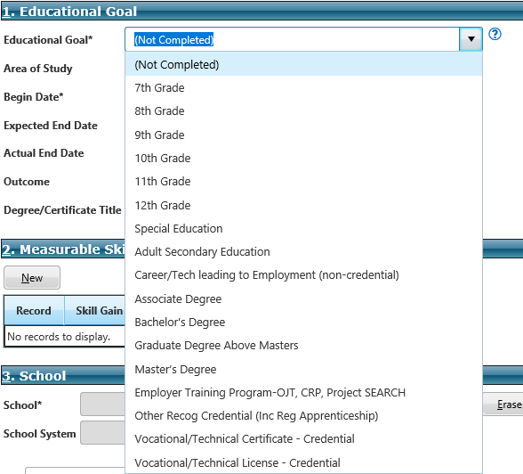

When selecting an educational goal for individuals in high school, the counselor will choose the grade level the individual is currently enrolled in. For individuals in post-secondary education, the counselor will select the credential the individual is working to achieve. For example, the counselor will select associate degree for an individual enrolled in an academic program in community college. For individuals enrolled as an undergraduate at a senior college, bachelor’s degree will be selected. For adults working towards their high school equivalency, the counselor will select Adult Secondary Education.

After selecting the appropriate educational goal from the drop-down menu, enter the individual’s chosen area of study, the begin date, and expected end date. The begin date should be the date the individual enrolled in PSED or training program. The expected end date is the date you anticipate the goal being completed. For example, if the educational goal is bachelor’s degree and the begin date is May 5, 2023, the expected end date should be May 5, 2027.

The remainder of the fields in section 1 (actual end date, outcome, degree/certificate title) will be completed when the individual achieves his/her educational goal or disenrolls from the PSED or training program.

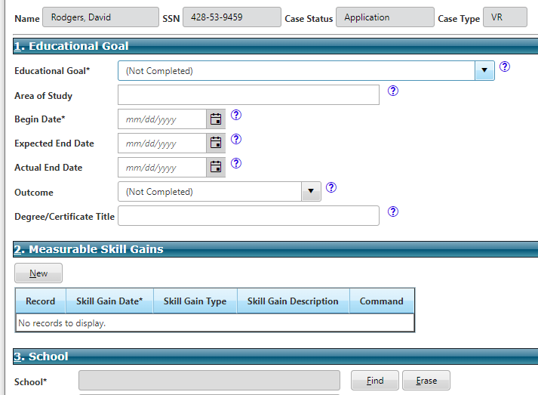
Section 2.

When recording the skill gain date, it is important to remember it must show the actual date the MSG was achieved, not when the counselor was notified. For example, if an individual graduates with his/her bachelor’s degree on May 10th, but the counselor doesn’t receive the supporting documentation (e.g., transcript) until June 1st, the counselor is still to enter the skill gain date as May 10th.

Next, the counselor must choose the skill gain type from the drop down menu and enter a brief description. See Appendix A at the end of this section for an explanation of the different skill gain types. Using the same example mentioned above, the counselor would choose Postsecondary Transcript/Report Card as the type and enter a description such as, received bachelor’s degree. Another example would be when an individual, with an educational goal of Master’s Degree, completes his/her first semester of graduate school and gives the counselor a grade report verifying the completion, the counselor would also choose Postsecondary Transcript/Report Card as the type, but would enter the description as something similar to “successful completion of 1st semester graduate school.”

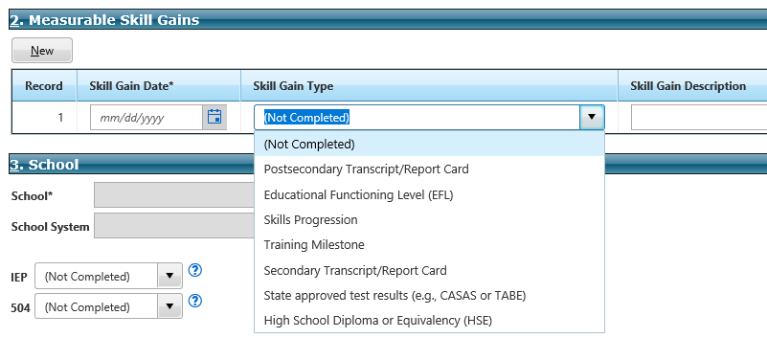

NOTE: To receive a MSG in PSED, an individual must take and pass a minimum of 12 semester hours in one semester or 12 hours over two completed semesters during a 12 month period. For PSED institutions that are on a trimester schedule, an individual must complete 9 hours in one trimester or 9 hours over the course of two trimesters within a 12 month period. However, if the individual takes less than the required number of hours during the appropriate time period or receives any grade lower than a D, a MSG is not earned for that semester/trimester.

Section 3.

This section is primarily for high school/transition students, however, counselors of individuals in PSED should click the “find” button to search for one of the following programs that best corresponds to the institution where the individual is enrolled.

PSED School Programs

- Postsecondary Technical School
- Postsecondary Academic School
- Employer Training Program
- Occupational Skills Program
- Pre-ETS Summer Work Program
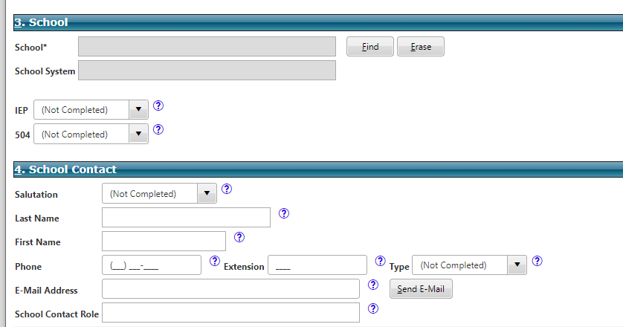

Sections 4 and 5 are optional. However, the best practice is to utilize the sections to capture school information and to comment on things of importance.
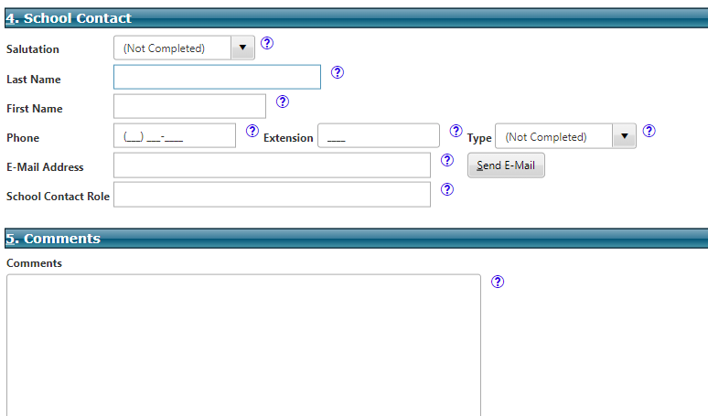

Outcome—The Completion of an Educational Goal

When an individual has completed his/her educational goal, the counselor must return to section 1 and complete the Actual End Date and Outcome fields. The Degree/Certificate Title field is optional.
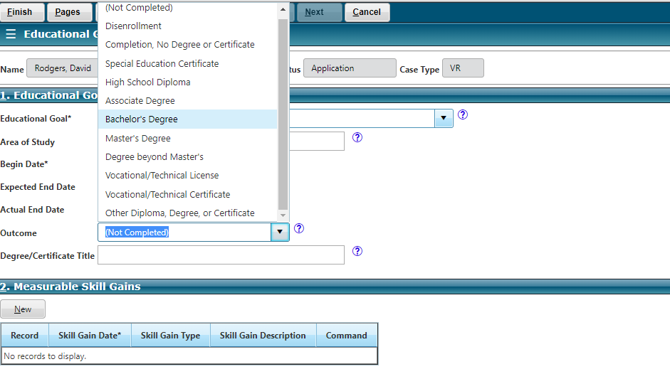

Counselors enter the actual date the individual achieved the goal, selects the corresponding outcome from the drop-down list, and if the individual received a degree/certificate, counselors may document the title accordingly, however, the title field is optional. For example, if an individual completes his/her goal and achieves an associate degree, the counselor will enter the date the individual graduated, choose associate degree from the drop-down menu and enter associate degree as the title of the degree received.

Internships/Placement Services for PSED Students

It is important for students to have actual, real-world work experience prior to achieving their chosen career goal. Having work experience increases their employability and ensures they are better prepared to meet the demands of full-time work.

Internships offer students a way to gain work experience, increase their practical knowledge, and develop the soft skills that employers value. The ideal time to participate in an internship is during the summer of a student’s last two (2) years of college training. However, internships are not limited to summers only and should be planned as needed for the individual student. It is prudent that counselors educate students concerning the benefits of internships and encourage them to participate.

The agency has Business Relations Specialists available to assist students in locating internship opportunities and permanent job placements after completion of their PSED program.

COMPREHENSIVE TRANSITION AND POST-SECONDARY EDUCATION PROGRAM

The Higher Education Opportunity Act (HEOA) of 2008 described and defined a new type of higher education program for students with intellectual disabilities: the Comprehensive Transition and Post-Secondary Education Program (CTP).

A program must meet the following requirements to be approved as a CTP (as outlined in the HEOA):

- Be delivered to students physically attending the institution of higher learning.
- Be offered by an institution of higher learning that is participating in Title IV Federal Student Aid.
- Be designed to support students with intellectual disabilities in preparation for employment.
- Include an advising and curriculum structure.
- Provide at least 50% of the program time in academics (college courses for credit or for audit, or internships) with other students without intellectual disabilities.

Requirements for entrance into a CTP differ slightly from the enrollment criteria of traditional postsecondary education programs, in that a high school diploma or GED is not required. An individual with a high school Special Education Certificate of Completion may attend a CTP.

PLANNING FOR CTP SERVICES

Best practices suggest the counselor gain input from the team working with the individual when developing the IPE. This could include the individual, their parent/legal guardian, the institution’s CTP Coordinator, and any others involved the individual may wish to be present.

The counselor should also ensure the training to be received from the CTP is consistent with the individual’s strengths, resources, priorities, concerns, abilities, capabilities, interests, informed choice, and necessary to achieve the individual‘s vocational goal.

Furthermore, individuals who attend a CTP are also subject to the same requirements as traditional students, including, but not limited to:

- Participation in Counseling and Guidance
- Annual completion of the FAFSA
- Adherence to the Standards for VR Sponsorship in Post-Secondary Education
(MDRS-VR-PSED-01) (with exception of the GPA and full-time status requirements)
- Costs as published in the Fee Schedule

When planning the CTP services, the counselor shall plan Training: Comprehensive Transition PSED Program and customize the description to indicate tuition and fees for the CTP. The counselor shall also plan Training: Comprehensive Transition PSED Program and customize the description to indicate books and related supplies for the CTP. Finally, as a foundation to independent living, CTP students are required to live on campus if housing is offered, therefore the counselor should plan Maintenance: Training Related and tailor the description to specify the exact assistance to be provided (i.e., dorm fee and/or meal plan).

The counselor plays a significant role in not only planning for CTP services, but also for facilitating the individual’s successful participation in the program. Each semester, the counselor and the individual should review the CTP’s curriculum to ensure it continues to support the individual’s chosen employment goal. Also, each semester, the individual and/or institution is to submit to the counselor a mid-term and final grade report detailing the individual’s progress. The counselor should review the grade report with the individual, their parent/legal guardian, and/or CTP Coordinator to determine what benefits the individual is receiving, what improvements or enhancements can and should be made to the individual’s current curriculum, and/or if participation in the CTP should continue.

Students in the CTP program are exempt from the FNA as it is not considered an academic program.

NOTE: Exceptions to the guidelines outlined in this section may be granted on a case-by-case basis, provided the individual's unique circumstances warrant such deviation. A written justification by the VR/VRB counselor and approval from the OVR district manager, OVRB regional manager or PSED Program Coordinator will be required.

AUTHORIZING FOR CTP SERVICES

Authorizations for a CTP’s tuition and fees should be issued to the educational institution using the same service category as stated on the plan (Training: Comprehensive Transition PSED Program). Authorizations for dorm fees and/or meal plans should also be issued to the educational institution using the same service category as the plan (Maintenance: Training Related) and the procedure codes: SN00084 –Dormitory and/or SN00085 – Meals.

Authorizations for books and supplies will be issued to a vendor of the individual’s choice using the service category stated on the IPE: Training: Comprehensive Transition PSED Program.

Exceptions to the guidelines outlined in this section may be granted on a case-by-case basis, provided the individual's unique circumstances warrant such deviation. A written justification by the VR/VRB counselor and approval from the OVR district manager, OVRB regional manager or PSED Program Coordinator will be required.

COMPLETION OF THE EDUCATION DATA PAGE

For CTP students, the Educational Goal should be CTP Program. Generally, these type programs are not eligible for MSGs. However, if a counselor believes an individual participating in a CTP program is learning industry specific skills or will be obtaining an industry specific credential, he/she should discuss the situation with his/her manager and the PSED Program Coordinator to determine if MSGs should be documented.

Upon completion of the entire CTP program, the counselor will document the individual’s educational outcome as CTP Certificate. However, if the individual does not successfully complete the CTP program, Disenrollment should be selected as the outcome.

APPENDIX A

FIVE TYPES OF MEASUREABLE SKILLS GAINS (MSGs)

Five types of MSGs are allowable under WIOA. The type of education or training program the individual is participating in will determine the type of measurable skills gain that could apply.

- Educational Functioning Level (EFL) Gain: Applies to an individual who is receiving instruction below the postsecondary education level. An EFL gain is the advancement of educational level by making measurable improvement in educational attainment as measured by a pre and post-test. An example would be moving from a 9th grade reading level to a 10th grade reading level. An example of a test used to determine this is the TABE.
Documentation Examples: Results from a pre- and post-test showing skills gains or academic improvement or enrollment in remedial training and then acceptance into a postsecondary educational training program.
- Attainment of a Secondary School Diploma or its Recognized Equivalent.
Documentation Examples: Copy of High School Diploma or High School Equivalency certificate or an official or unofficial transcript or report card showing the date the diploma/equivalency was received.
- Secondary or Post–Secondary Transcript/Report Card: A transcript or a report card demonstrating the following based upon enrollment status:
Secondary-
- Passing grades of a D or above in all classes
Post-Secondary-
- Full Time Student – completion of a minimum of 12 hours for one semester
- Part-Time Student – completion of a minimum of 12 credit hours in two semesters over the course of a 12-month period.
NOTE: For PSED institutions that are on a trimester schedule, an individual must complete 9 hours in one trimester or 9 hours over the course of two trimesters within a 12-month period. However, if the individual takes less than the required number of hours during the appropriate time period or receives any grade lower than a D an MSG is not earned for that semester/trimester.
Documentation Examples: Transcript or report card showing the credit levels were achieved and that the individual was in good academic standing.
- Training Milestone: Satisfactory or better progress towards established milestones while participating in an OJT, Registered Apprenticeship program, Business Enterprise program, or Employer Training program.

Documentation Examples: Employer provides documentation of successful completion of an OJT or one year of an apprenticeship program, or a report provided by OVRB of progress made in BEP program.
- Skills Progression: Successful passage of an exam required for a particular occupation or progress in attaining trade-related benchmarks, such as knowledge-based exams. Examples include CRC or NCE exams, CDL, and passing a welding certification exam.
Documentation Examples: Copy of exam results indicating a passing score or trade related exam results indicating passing score.

